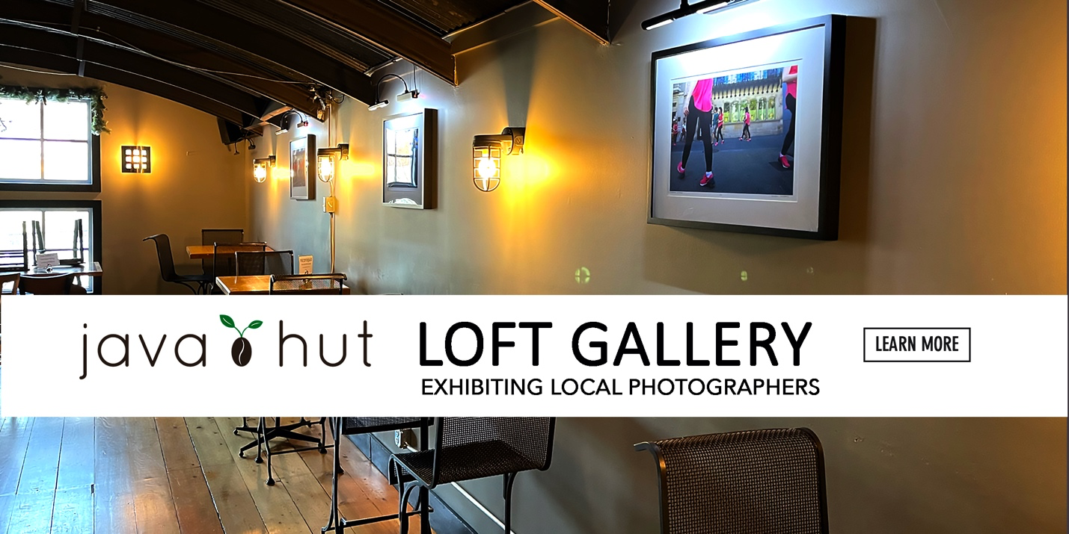

OUR PRECIOUS PARKS – TREASURES OF BEAUTY
by PETER OTIS through May 11

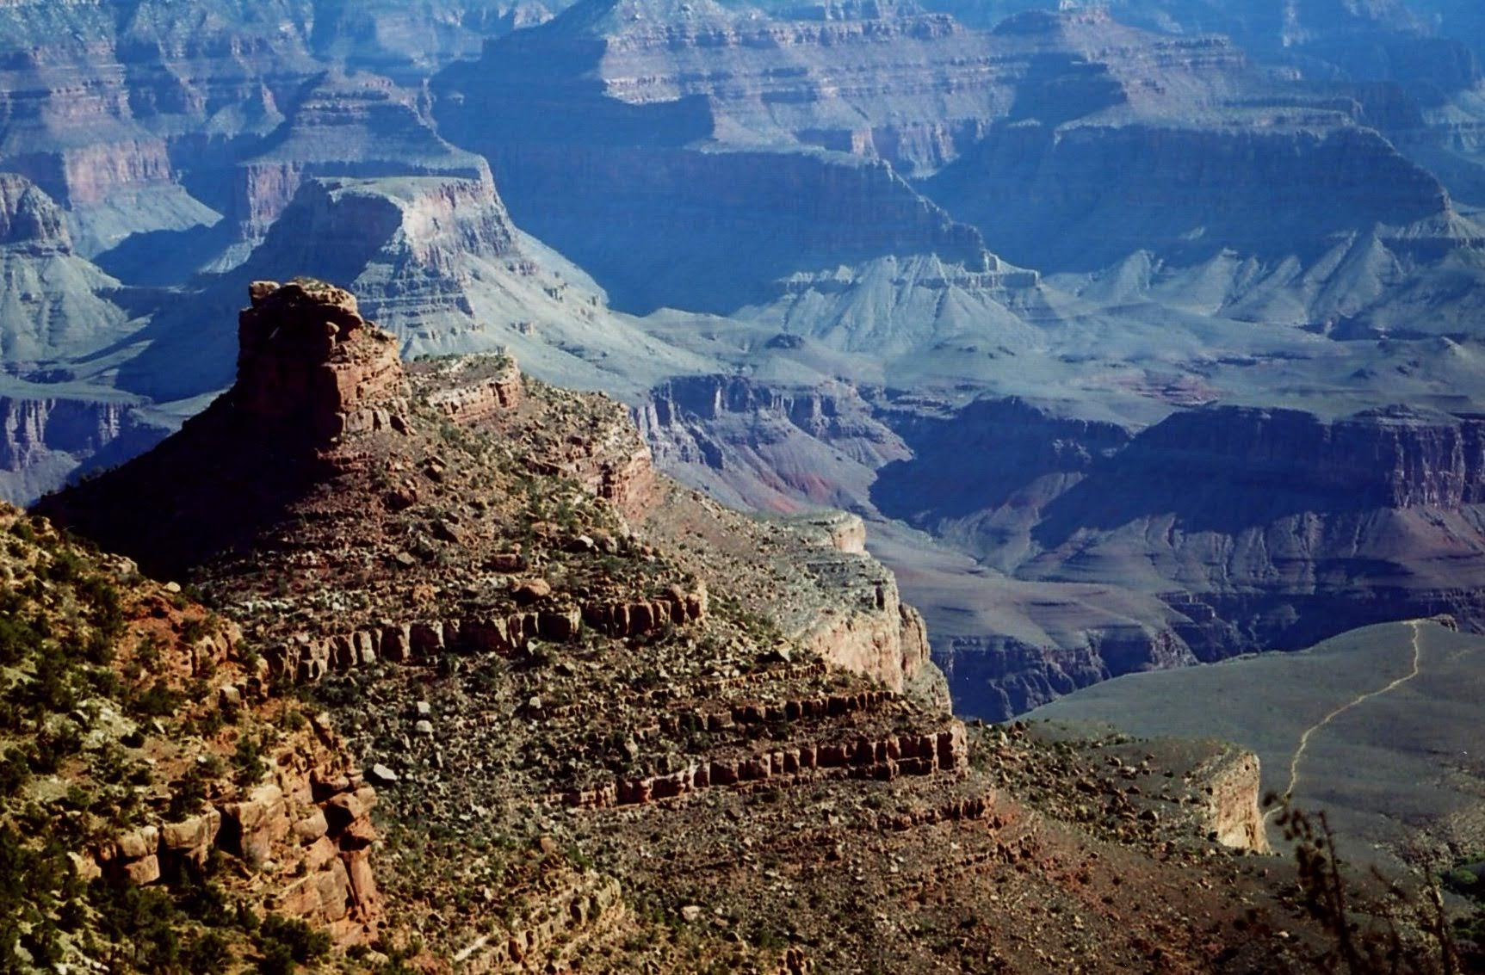 | 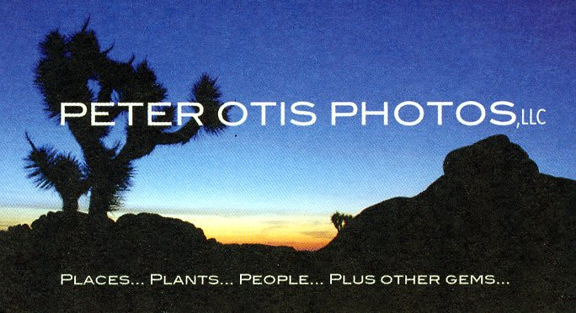
Ken Burns’ spectacular series – The National Parks: America’s Best Idea – highlights the beauty and significance that is ours in the U.S. Sixty three national parks and many more monuments and historic sites make up the 423 national park holdings. Add to this collection state and municipal parks that are for us. We are blessed! Distilling my images from 32 national parks and even more monuments has been a sizeable task. Of my 6 images upstairs 2 are from state parks, and 2 show the fascination our grandkids experienced in these settings. Sharing my love of these special places is another important joy filled focus.

peter@peterotisphotos.com www.peterotisphotos.com

Peter Otis is a Guilford resident and photographer. Displays and publication highlights include: Yale University and Yale School of the Environment, Guilford Land Conservation Trust, Trinity Episcopal Church – Branford, University of New Hampshire, Willoughby Wallace Memorial Library, Branford Arts and Cultural Alliance, Guilford’s 375th, Shoreline Times, Mashantucket Museum News, The Chronicle of Higher Education, and his peterotisphotos.com website.
Loft Gallery exhibits are organized by Michael Haggans – jmhaggans@gmail.com
Also on display downstairs are oil paintings of local landmarks by Jeffrey Suraci
jeffsuraci@yahoo.com
JAVA HUT CAFÉ & BISTRO - 20 CHURCH STREET, GUILFORD - javahutcafebistro.com

